Wireless Extension Board

This wireless extension board can control four actuators via android mobile application and consists of following components:

* Wooden/ plastic extension board (8 channel).
* 2 pin socket (4 pieces).
* 220V AC wire.
* 4 channel relay.
* 220V AC to 5V DC converter circuit.
* ESP32/ESP8266.
* Female header base.
* Veroboard.
* 6 pin female connector with wire.

Following are the hardware tools we need to setup the hardware:

* Soldering iron
* Soldering wire
* Hot glue gun
* Hot glue stick
* Multimeter for troubleshooting.

**Software Instructions**

Laptop or PC can be used to prepare the software for ESP32/8266 and android mobile application.

Android mobile application to control 4 sockets individually was built on Flutter software on VS code and for simulation the Android Emulator of Android Studio is used.

The android mobile application is provided in the folder. You just need to do is to copy it in your mobile and then install it.

The library provided ***arduinoWebSockets*** in the code folder must needs to be placed in the Arduino library folder of the host.

Connect ESP32/8266 to the host machine by USB type B micro cable.

Open the code and make sure you have selected the **ESP32 Dev Module** board in the Arduino IDE and also select the correct **port**.

You can change the ***ssid*** and ***pass*** of the ESP32/8266 board by removing the default strings that are “*esp_wifi*” and “*44445555*”.

Now just upload the program by clicking the tick button at top left corner right below file tab.

Press the boot button on ESP32/8288 board until program starts to upload.

When program is finished uploading then check in your mobile that are you getting your ESP username or not. If yes then you have successfully uploaded the program.

**Hardware Instructions**

Break the 40 pin female header into two pieces and sold it on veroboard, such that ESP32/8266 could equally sit on it.

Now sold 6 pin female connector with wire such that the fist wire is soldered to Vin of MCU and then the four wires are soldered to pins 12, 14, 27, 26 of MCU and the last wire is soldered to the ground of MCU.

And now plug this 6 pin female connector into the 6 pin control header.

For powering the MCU and relay module just connect the Vin and ground pins of MCU to the Vin and GND pins of 220V AC to 5V DC circuit and also make first by multimeter that the connections you making are correct.

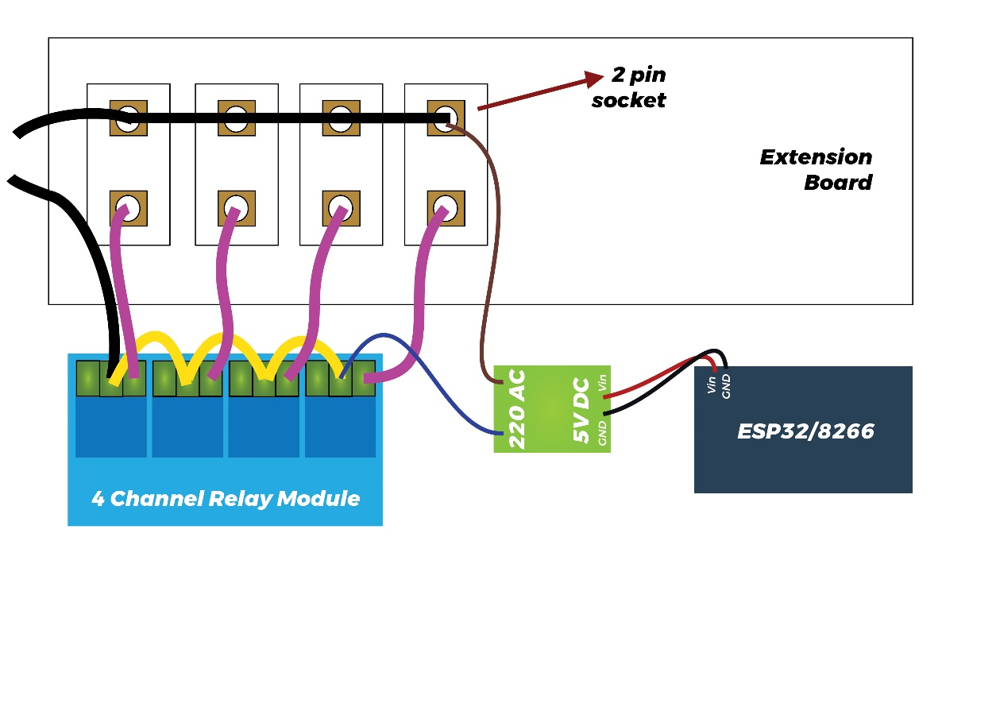For AC connection between relay module and female sockets follow the diagram given below.

**Working**

Make sure the wifi of ESP32/8266 is connected on your android mobile. After that just toggle the buttons in application to power the load up or down.